**Using the Remote Server Administration Tools**

**Time Required:** Approximately 10 minutes

**Objective:** Learn how to use the Remote Server Administration Tools capability.

**Description:** Many of the MMC snap-ins can be implemented using the Remote Server Administration Tools capability. In this activity, you learn how to use the remote administration capability via two sample snap-ins, the DNS and the Performance Monitor MMC snap-ins. It is not necessary to have another server to remotely access, because you’ll simply learn how to use the remote access capability.

1. Right-click **Start** and click **Run**.
2. Type **mmc** in the Open text box and click **OK**.
3. Click the **File** menu and click **Add/Remove Snap-in**.
4. In the Add or Remove Snap-ins dialog box, click **DNS** and click the **Add** button.
5. Click **Performance Monito**r and click **Add**.
6. Click **OK** in the Add or Remove Snap-ins dialog box.
7. In the Console1— [Console Root] window, click DNS in the tree.
8. Click the **Action** menu and click Connect to DNS Server.
9. You see the Connect to DNS Server dialog box (see Figure 12-18). To connect to another server that offers DNS services, you would click the option button for The following computer and then enter the name of the server on which to use the DNS management tool. In this case, the Connect to DNS Server dialog box represents the implementation of the Remote Server Administration Tool, DNS Server Tools (which is transparent other than using this dialog box to remotely connect). Click **Cancel**.

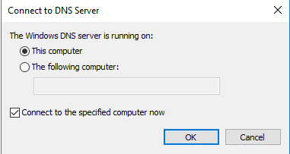

1. Another way to remotely connect to a server to use the DNS Server Tools is to use the right pane. In the right pane, click More Actions under DNS and click **Connect to DNS Server**.
2. When you see the Connect to DNS Server dialog box, click **Cancel**.
3. Click **Performance (Local)** in the tree.
4. Click the **Action** menu and click **Connect to another computer**.
5. You see the Select Computer dialog box. In this dialog box you can select to connect to the local computer or to a remote computer. To connect to a remote computer, you can type its name in the box or use the **Browse** button to find and select the local computer on the network.

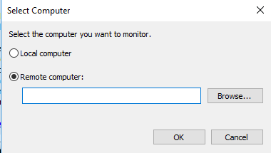

1. Click **Cancel** in the Select Computer dialog box.
2. Click **More Actions** in the right pane and click **Connect to another computer** to view another way to open the Select Computer dialog box.
3. Click **Cancel** in the Select Computer dialog box.
4. Close the Console1 — [Console Root] window.
5. Click **No** so that the console settings are not saved.